SIMPLE: Create a task on the update of an incident

Starting point: incident ID 1
[Onyx-Vanilla; added Sales Incident ProductNumber = “salesProd”, Description = “Default”]]

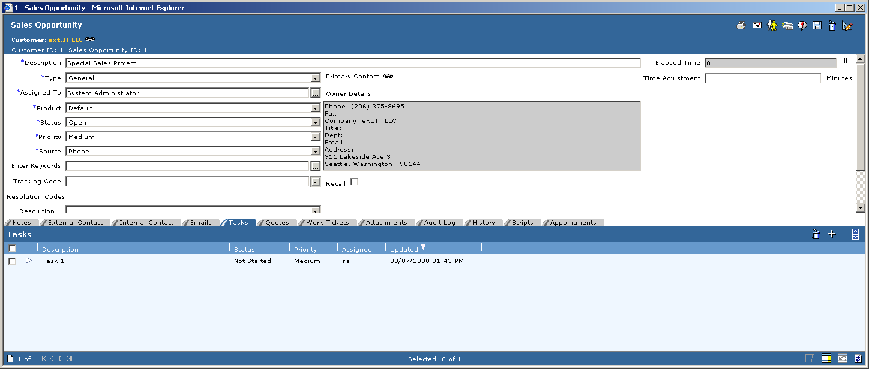

- Add this step to OED on incident.update:
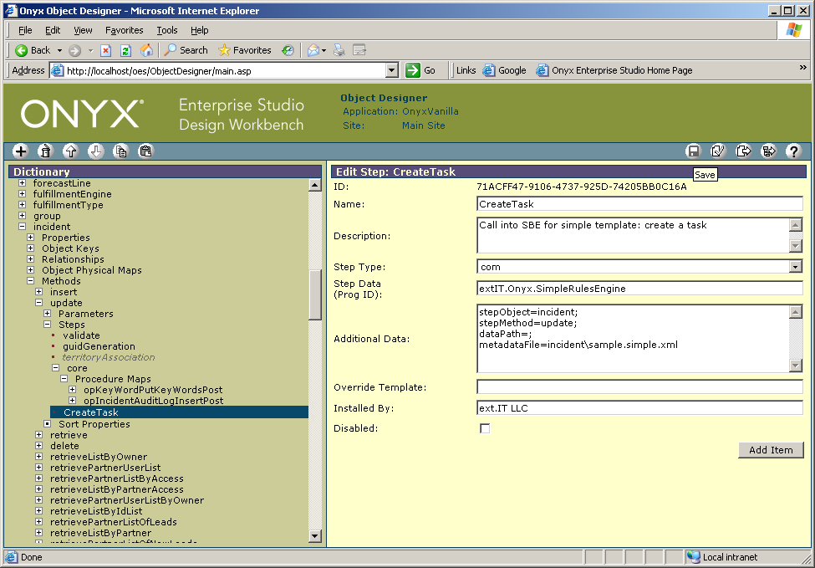

- Publish the OED
- Now create directory c:\temp [for the log outputs defined in the metadata XML]
- Save file sample.simple.xml in
C:\Program Files\Onyx\AppServer\Applications\Onyx\simpleRules\metadata\incident
- Run incident.update in LBOTester
- Check for created task

File
C:\Program Files\Onyx\AppServer\Applications\Onyx\simpleRules\metadata\incident\sample.simple.xml:

<rules description="sample.simple.xml - On incident.update, create a task">
<saveXML mode="development" description="Log the input XML">
<name>
<literal>c:\temp\sample.simple__INPUT.xml</literal>
</name>
<path>
<literal>/stepPackage</literal>
</path>
</saveXML>

<otmCall description="Call task.insert">
<object>
<literal>task</literal>
</object>
<method>
<literal>insert</literal>
</method>
<inputParameters description="Add parameters to for the insert of the task">
<objectInstance description="Get an empty XML for task">
<path>
<literal>.</literal>
</path>
<name>
<literal>task</literal>
</name>
</objectInstance>
<setNodeValue description="Set owner ID to incident-ID">
<path>
<literal>task/ownerId</literal>
</path>
<value>
<getNodeValue>
<literal>//parameters/incident/primaryId</literal>
</getNodeValue>
</value>
</setNodeValue>
<setNodeValue description="Set assigned to = Assigned To from incident">
<path>
<literal>task/assignedTo</literal>
</path>
<value>
<getNodeValue>
<literal>//parameters/incident/assignedTo</literal>
</getNodeValue>
</value>
</setNodeValue>

<setNodeValue description="Set owner type to incident">
<path>
<literal>task/ownerType</literal>
</path>
<value>
<literal>6</literal>
</value>
</setNodeValue>
<setNodeValue description="Set category ID = Sales Task">
<path>
<literal>task/categoryId</literal>
</path>
<value>
<literal>13</literal>
</value>
</setNodeValue>
<setNodeValue description="Set task description">
<path>
<literal>task/description1</literal>
</path>
<value>
<literal>Auto-created via incident.update</literal>
</value>
</setNodeValue>
<setNodeValue description="Set type = Follow-up">
<path>
<literal>task/typeId</literal>
</path>
<value>
<literal>192</literal>
</value>
</setNodeValue>
<setNodeValue description="Set status = Open">
<path>
<literal>task/statusId</literal>
</path>
<value>
<literal>130</literal>
</value>
</setNodeValue>
<setNodeValue description="Set priority = High">
<path>
<literal>task/priorityId</literal>
</path>
<value>
<literal>118</literal>
</value>
</setNodeValue>

<saveXML mode="development" description="Log target contents to file">
<name>
<literal>c:\temp\otmCall.task.insert.target.xml</literal>
</name>
<path>
<literal>.</literal>
</path>
<source>target</source>
</saveXML>

</inputParameters>
<outputParameters description="Work on result from task.insert">

<saveXML mode="development" description="Log result contents to file">
<name>
<literal>c:\temp\otmCall.task.insert.result.xml</literal>
</name>
<path>
<literal>.</literal>
</path>
</saveXML>

</outputParameters>
<onError>stop</onError>
</otmCall>
</rules>

